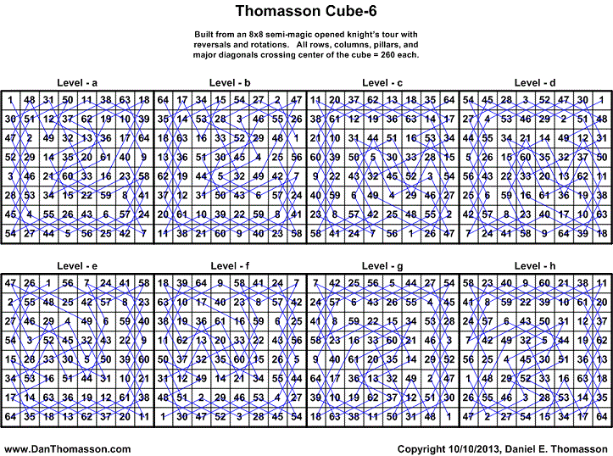
abcdefgh | adcgbfeh | afgdebch | bcaedhfg | befahcdg | bhfedcag | cdbahgef | cgehadbf | dbacfhge | dfbhagce
abcedfgh | adfbgceh | afgedbch | bcdahefg | befhacdg | cabdeghf | cdbhagef | cghdeabf | dbafchge | dfgahbce
abdcfegh | adfgbceh | agcdefbh | bcdhaefg | behcfadg | cabedghf | cdgahbef | cghedabf | dbcahfge | dfghabce
abdfcegh | adgcfbeh | agcedfbh | bceahdfg | behfcadg | cadbgehf | cdghabef | chbdegaf | dbchafge | dfhbgace
abecfdgh | adgfcbeh | agdcfebh | bcehadfg | bfadehcg | cadgbehf | cdhbgaef | chbedgaf | dbfahcge | dfhgbace
abefcdgh | aebcfgdh | agdfcebh | bchdeafg | bfaedhcg | caebgdhf | cdhgbaef | chdbgeaf | dbfhacge | dgacfhbe
abfdecgh | aebfcgdh | agecfdbh | bchedafg | bfdahecg | caegbdhf | ceabghdf | chdgbeaf | dbhcfage | dgafchbe
abfedcgh | aecbgfdh | agefcdbh | bdacfheg | bfdhaecg | cagdebhf | ceagbhdf | chebgdaf | dbhfcage | dgcahfbe
acbdegfh | aecgbfdh | agfdecbh | bdafcheg | bfeahdcg | cagedbhf | cebahgdf | chegbdaf | dcabghfe | dgchafbe
acbedgfh | aefbgcdh | agfedcbh | bdcahfeg | bfehadcg | cbadehgf | cebhagdf | chgdebaf | dcagbhfe | dgfahcbe
acdbgefh | aefgbcdh | bacdefhg | bdchafeg | bfhdeacg | cbaedhgf | cegahbdf | chgedbaf | dcbahgfe | dgfhacbe
acdgbefh | aegcfbdh | bacedfhg | bdfahceg | bfhedacg | cbdahegf | ceghabdf | dabcfghe | dcbhagfe | dghcfabe
acebgdfh | aegfcbdh | badcfehg | bdfhaceg | bhcdefag | cbdhaegf | cehbgadf | dabfcghe | dcgahbfe | dghfcabe
acegbdfh | afbdegch | badfcehg | bdhcfaeg | bhcedfag | cbeahdgf | cehgbadf | dacbgfhe | dcghabfe | dhbcfgae
acgdebfh | afbedgch | baecfdhg | bdhfcaeg | bhdcfeag | cbehadgf | cgadehbf | dacgbfhe | dchbgafe | dhbfcgae
acgedbfh | afdbgech | baefcdhg | beacfhdg | bhdfceag | cbhdeagf | cgaedhbf | dafbgche | dchgbafe | dhcbgfae
adbcfgeh | afdgbech | bafdechg | beafchdg | bhecfdag | cbhedagf | cgdahebf | dafgbche | dfabghce | dhcgbfae
adbfcgeh | afebgdch | bafedchg | becahfdg | bhefcdag | cdabghef | cgdhaebf | dagcfbhe | dfagbhce | dhfbgcae
adcbgfeh | afegbdch | bcadehfg | bechafdg | bhfdecag | cdagbhef | cgeahdbf | dagfcbhe | dfbahgce | dhfgbcae
 |  |  |  |  |  |  |  |  | dhgcfbae
384 Solutions with 192 reflections – © 10/10/2013 Daniel E. Thomasson |  |  |  |  |  |  |  |  | dhgfcbae

