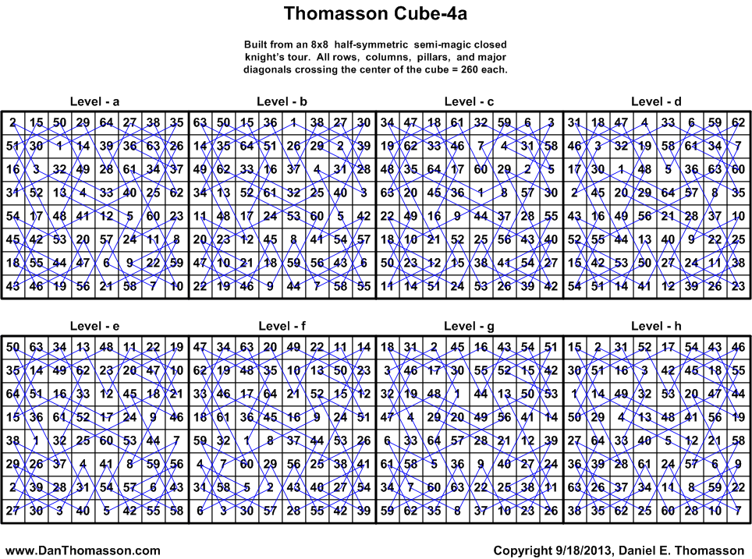
abcdefgh | acbfgehd | acgebdfh | adchbgfe | aecgfhbd | afcdebgh | afghbcde | agecdfhb | ahebcfgd | badcghef
abcdfehg | acbhegfd | acgebfdh | adchefgb | aecgfhdb | afcdhgbe | afghdcbe | agecdhfb | ahebdgfc | badchgfe
abcdghef | acdbegfh | acgedbfh | adebfchg | aedbgchf | afchbgde | afghebcd | agfbcehd | ahebfcdg | badecfgh
abcdhgfe | acdbgehf | acgedfbh | adebghcf | aedfgchb | afchdgbe | afghedcb | agfbecdh | ahebgdcf | badehgfc
abcfdehg | acdfgehb | acgehbfd | adefbchg | aefbcghd | afchebgd | agbdecfh | agfdcehb | ahedbgfc | badgchef
abcfghed | acdhegfb | acgehdfb | adefghcb | aefdcghb | afchedgb | agbhecfd | agfdecbh | ahedcfgb | badgfehc
abchdgfe | acegbdhf | acgehfbd | adgbefch | aegcbfhd | afebchgd | agcebdfh | agfhecbd | ahedfcbg | bafcedgh
abchefgd | acegbhdf | acgehfdb | adgbhcfe | aegcbhfd | afebdghc | agcebfdh | agfhecdb | ahedgbcf | bafchgde
abedfchg | acegdbhf | achbgedf | adghbcfe | aegcdfhb | afedbghc | agcedbfh | aghbcefd | ahefbcdg | bafecdgh
abedghcf | acegdhbf | achdgebf | adghefcb | aegcdhfb | afedchgb | agcedfbh | aghdcefb | ahefdcbg | bafehgdc
abefdchg | acegfbhd | achfgebd | aebdgchf | aehbcgfd | afgbched | agcehbfd | ahcbfedg | ahefgbcd | bahcfedg
abefghcd | acegfdhb | achfgedb | aebfgchd | aehbgcdf | afgbdehc | agcehdfb | ahcbgdef | ahefgdcb | bahcgdef
abgdefch | acegfhbd | adcbefgh | aecgbdhf | aehdcgfb | afgbedch | agcehfbd | ahcdfebg | ahgbcfed | bahgcdef
abgdhcfe | acegfhdb | adcbfehg | aecgbhdf | aehdgcbf | afgbhcde | agcehfdb | ahcdgbef | ahgbdefc | bahgfedc
abghdcfe | acfbegdh | adcbghef | aecgdbhf | aehfgcbd | afgdbehc | agdbecfh | ahcfbedg | ahgdbefc | bcdaefgh
abghefcd | acfdegbh | adcbhgfe | aecgdhbf | aehfgcdb | afgdcheb | agdhecfb | ahcfdebg | ahgdcfeb | bcdafehg
acbdegfh | acfhegbd | adcfbehg | aecgfbhd | afcbedgh | afgdebch | agecbfhd | ahcfgbed | badcefgh | bcdaghef
acbdgehf | acfhegdb | adcfgheb | aecgfdhb | afcbhgde | afgdhcbe | agecbhfd | ahcfgdeb | badcfehg | bcdahgfe
1280 Solutions with 640 reflections - © 09/18/2013 Daniel E. Thomasson – Continued on next page
bcdeafgh | behcafgd | bhdfaecg | cbefdahg | cfgdhabe | dahcgbef | dfbhcgae | ebcfgdah | egbdacfh | fdbheacg
bcdgahef | behcfadg | bhdfcaeg | cbefghad | cfghbade | dahgcbef | dfcahbge | ebcfhadg | egbdcafh | fdbhecag
bcfaedgh | behcgdaf | bhdfceag | cbgdefah | cfghdabe | dbacfheg | dfgahbce | ebchfadg | egcabdfh | fdcabheg
bcfahgde | behgadcf | bhdfgaec | cbgdhafe | cfghebad | dbachfge | dfgchbae | ebchgdaf | egcabfdh | fdcehbag
bcfeadgh | behgcdaf | bhdfgeac | cbghdafe | cgaebdfh | dbcafheg | dgbaefch | ebgdafch | egcadbfh | fdeabhcg
bchafedg | behgfadc | bheadfgc | cbghefad | cgaebfdh | dbcahfge | dgbahcfe | ebgdcfah | egcadfbh | fdecbhag
bchagdef | bfachdge | bheafdcg | cdabefgh | cgaedbfh | dbeafhcg | dgbcefah | ecagfbdh | egdbacfh | fdhbaceg
bchgadef | bfaehdgc | bhecfdag | cdabfehg | cgaedfbh | dbecfhag | dgbchafe | ecagfdbh | egdbcafh | fdhbaecg
bdacfheg | bfcahdge | bhegfdac | cdabghef | cgaehbfd | dbfhacge | dgbeafch | ecaghbdf | egfbacdh | fdhbcaeg
bdachfge | bfdhacge | bhfdaegc | cdabhgfe | cgaehfbd | dbfhagce | dgbecfah | ecaghdbf | egfbcadh | fdhbceag
bdaehfgc | bfdhagce | bhfdagec | cdafbehg | cgbdeafh | dbfhcage | dgfaebch | ecbdagfh | egfdacbh | febadchg
bdagfhec | bfdhcage | bhgadfec | cdahbgfe | cgbheafd | dbfhcgae | dgfahcbe | ecbfgadh | egfdcabh | febcdahg
bdcafheg | bfdhcgae | cabdegfh | cdebfahg | cgdbeafh | dbgahfce | dgfcebah | ecbhgadf | fabcdehg | fedabchg
bdcahfge | bfdheagc | cabdgehf | cdebghaf | cgeabfhd | dbgchfae | dgfchabe | ecdbagfh | fabegdch | fedcbahg
bdeafhcg | bfdhegac | cabfgehd | cdefbahg | cgeabhfd | dbhfaceg | dgfeabch | ecdfgabh | fabehcdg | fehabcdg
bdecfhag | bfeadhgc | cabhegfd | cdgbefah | cgfbaehd | dbhfaecg | dgfecbah | ecdhgabf | fabgedch | fehadcbg
bdegfhac | bfgadhec | cadbegfh | cdgbhafe | cgfbeadh | dbhfcaeg | dhacfbeg | ecfbagdh | fadcbehg | fehcbadg
bdfhacge | bfgahdce | cadbgehf | cdghbafe | cgfdeabh | dbhfceag | dhbfaceg | ecfdagbh | fadegbch | fehcdabg
bdfhagce | bfgchdae | caegbdhf | ceagbdhf | cgfheabd | dcbaefgh | dhbfaecg | ecgabdfh | fadehcbg | fhacbdeg
bdfhcage | bfgehdac | caegbhdf | ceagbhdf | cghbaefd | dcbafehg | dhbfcaeg | ecgabfdh | fadgebch | fhacdbeg
bdfhcgae | bfhdaegc | caegdbhf | ceagdbhf | chabfedg | dcbaghef | dhbfceag | ecgadbfh | fahcbedg | fhbdaceg
bdfheagc | bfhdagec | caegdhbf | ceagdhbf | chabgdef | dcbahgfe | dhcafbeg | ecgadfbh | fahcdebg | fhbdaecg
bdfhegac | bgdaefch | caegfbhd | ceagfbhd | chadfebg | dcbeafgh | dheafbcg | edabcfgh | fbacdheg | fhbdcaeg
bdgahfce | bgdahcfe | caegfhbd | ceagfhbd | chadgbef | dcbgahef | dhecfbag | edafgbch | fbaehdcg | fhbdceag
bdgchfae | bgdcefah | cafbegdh | cebdgahf | chafbedg | dcfaebgh | eabdcgfh | edafhcbg | fbcadheg | fhcabdeg
bdgehfac | bgdchafe | cafdegbh | cebfgahd | chafdebg | dcfahgbe | eabfgcdh | edahfcbg | fbcehdag | fhcadbeg
bdhfaceg | bgdeafch | cafhegbd | cedbgahf | chafgbed | dcfeabgh | eabhgcdf | edahgbcf | fbdheacg | fhdbaceg
bdhfaecg | bgdecfah | cagebdfh | cefbaghd | chebafgd | dchafebg | eacgfbdh | edcbafgh | fbdhecag | fhdbaecg
bdhfcaeg | bgdehafc | cagebfdh | cegabfhd | chebfadg | dchagbef | eacgfdbh | edcfgbah | fbeadhcg | fhdbcaeg
bdhfceag | bgfached | cagedbfh | cegabhfd | chebgdaf | dchgabef | eacghbdf | edcfhabg | fbecdhag | fhdbceag
bdhfgaec | bgfadehc | cagedfbh | cehbagfd | chedfabg | debafchg | eacghdbf | edchfabg | fbhdaceg | fheabdcg
bdhfgeac | bgfaedch | cagehbfd | cehbgadf | chedgbaf | debaghcf | eadbcgfh | edchgbaf | fbhdaecg | fheadbcg
bedafchg | bgfahcde | cagehfbd | cehdgabf | chefbadg | debcfahg | eadfgcbh | edgbafch | fbhdcaeg | fhecbdag
bedaghcf | bgfcahed | cahbgedf | cehfgabd | chefdabg | debcghaf | eadhgcbf | edgbcfah | fbhdceag | fhecdbag
bedcfahg | bgfcedah | cahdgebf | cfabedgh | chefgbad | debgahcf | eafbcgdh | efabcdgh | fcbadehg | gabfecdh
bedcghaf | bgfchade | cahfgebd | cfabhgde | chgbafed | debgchaf | eafdcgbh | efadcbgh | fcbegdah | gacefbdh
bedgahcf | bgfeadch | cbadefgh | cfadebgh | dabcefgh | dehafcbg | eagcbdfh | efcbadgh | fcbehadg | gacefdbh
bedgchaf | bgfecdah | cbadfehg | cfadhgbe | dabcfehg | dehagbcf | eagcbfdh | efcdabgh | fcbgedah | gadfecbh
bedgfahc | bgfehadc | cbadghef | cfahbgde | dabcghef | dehcfabg | eagcdbfh | efgbadch | fcdabehg | gbafedch
befachgd | bghacfed | cbadhgfe | cfahdgbe | dabchgfe | dehcgbaf | eagcdfbh | efgbcdah | fcdegbah | gbcfedah
befadghc | bghadefc | cbafdehg | cfahebgd | dabecfgh | dehgabcf | ebadcfgh | efgdabch | fcdehabg | gcaefbdh
befcahgd | bghcafed | cbafghed | cfebahgd | dabgchef | dehgcbaf | ebafgdch | efgdcbah | fcdgebah | gcaefdbh
behacfgd | bhacfdeg | cbahdgfe | cfgbahed | dafcebgh | dfachbge | ebafhcdg | egacbdfh | fchabedg | gcbfeadh
behadgfc | bhagfdec | cbahefgd | cfgbedah | dafchgbe | dfbhacge | ebahfcdg | egacbfdh | fchadebg | gcdfeabh
behafcdg | bhcafdeg | cbedfahg | cfgbhade | dafecbgh | dfbhagce | ebahgdcf | egacdbfh | fdacbheg | gdafebch
behagdcf | bhdfaceg | cbedghaf | cfgdebah | dahcfebg | dfbhcage | ebcdafgh | egacdfbh | fdaehbcg | gdcfebah
1280 Solutions with 640 reflections - © 09/18/2013 Daniel E. Thomasson

