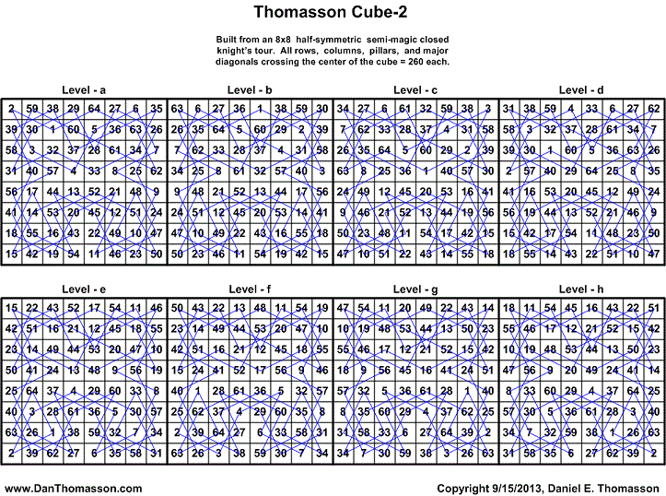
abcdefgh | aecghdfb | ahgbfcde | befagdch | cabdfhge | cdhbgaef | dabcehgf | dfechbag | ebcadgfh | fbaegcdh
abcdhgfe | aefbcghd | badcfehg | bfdhaecg | cabdhfeg | ceagbhdf | dabcfghe | dfghabce | ebcfgdah | fbaehdcg
abcedfgh | aefbdhgc | badcghef | bfeacghd | cabefhgd | cefdgabh | dabcgfeh | dgacebhf | ebhcdgaf | fbcegadh
abcehgfd | aefbgcdh | badfcehg | bfeadhgc | cadbfheg | cefdhbag | dabchefg | dgcaebfh | ecbadfgh | fbcehdag
acbdhfge | aefbhdcg | badfghec | bfeagcdh | cagdfhbe | cehgbadf | dabfcghe | dghcebaf | ecbfgadh | fcbehadg
acbehfgd | afebchgd | bcdaehgf | bfeahdcg | cagefhbd | cfedhabg | dagcehbf | dhbceagf | ecbfhdag | fcdehabg
acdbfhge | afebhcdg | bcdafghe | bgcaedhf | cbadehgf | cgadehbf | dagcfbhe | dhbcfgae | ecdfgabh | fdabcehg
acdbhfeg | agcbehdf | bcdagfeh | bghadefc | cbadfghe | cgadfbhe | dagfcbhe | dhbfcgae | ecdfhbag | fdaegcbh
aceghfdb | agcbfdhe | bcdahefg | bghaedcf | cbadgfeh | cgaedhbf | dbaceghf | dhgceabf | ecgadfbh | fdaehbcg
acgbfhde | agcdefbh | bcgaehdf | bhdaecgf | cbadhefg | cgaefbhd | dbacgefh | dhgcfbae | edafgbch | fdcegabh
acgdhfbe | agcdhbfe | bcgafdhe | bhdafgce | cbaedhgf | cghdeabf | dbcaegfh | dhgfcbae | edcfgbah | fdcehbag
acgehfbd | agcedfbh | bdacgehf | bhdcfeag | cbaefghd | cghdfbae | dbhcegaf | eabcdhgf | egacdbhf | fdhbceag
adcbehgf | agcehbfd | bdafgehc | bhdcgaef | cbhdeagf | cghedabf | dcbaefgh | eabfgcdh | egcadbfh | fhdbcaeg
adcbfghe | aghbcefd | bdcaeghf | bhdfceag | cbhdfgae | cghefbad | dcbahgfe | eabfhdcg | eghcdbaf | gceabfdh
adcbgfeh | aghbdfec | bdcagefh | bhdfgaec | cbhedagf | chbdfage | dcgaefbh | eadfgcbh | ehbcdagf | gecabdfh
adcbhefg | aghbecdf | bdhaegcf | bhgacefd | cbhefgad | chbefagd | dcgahbfe | eadfhbcg | ehgcdabf
adhbecgf | aghbfdce | bdhcgeaf | bhgadfec | cdabfehg | chdbfaeg | defcgbah | eagcdhbf | fabehcdg
adhbfgce | ahdbfcge | bdhfgeac | bhgaecdf | cdabghef | chgdfabe | dfbhagce | ebacdghf | fadbcheg
aecgbfdh | ahgbcfed | befadghc | bhgafdce | cdhbfeag | chgefabd | dfecgabh | ebafgdch | fadehcbg
372 Solutions with 186 reflections - © 09/15/2013 Daniel E. Thomasson

